Lab 15

Monkey Banana Problem
Aim: Write a program to solve the Monkey Banana problem.
The Monkey and Banana Problem is a well-known problem in Artificial Intelligence that illustrates state-space search through logic programming. In the problem, a monkey is in a room with a banana suspended from the ceiling and a box somewhere in the room. The monkey cannot reach the banana directly but can move, push the box, climb on it, and hold the banana if placed appropriately. Each of the states in the problem is denoted by the position of the monkey, the position of the box, whether the monkey is on the box or on the floor, and whether the monkey has the banana or not. The target state is where the monkey is on the box and has the banana. The problem demonstrates some important AI ideas such as planning, backtracking, and rule-based reasoning using Prolog.

Facts | Rules | Query
goal(state(_,_,onbox, hasbanana)).  moveMonkey(left, middle). moveMonkey(middle, left). moveMonkey(middle,  right).  moveMonkey(right, middle). | move(state(Monkey, Box, onfloor, hasnot), NewState) :- moveMonkey(Monkey, NewMonkey),  NewState = state(NewMonkey, Box, onfloor, hasnot).  push(state(Monkey, Monkey, onfloor, hasnot), NewState) :-  moveMonkey(Monkey, NewMonkey),  NewState = state(NewMonkey, NewMonkey, onfloor, hasnot).  climb(state(Pos, Pos, onfloor, hasnot), state(Pos, Pos, onbox, hasnot)).  grasp(state(middle, middle, onbox, hasnot), state(middle, middle, onbox, hasbanana)).  plan(State, _, []) :- goal(State).  plan(State, Visited, [Action | Rest]) :- action(Action, State, NextState),  \+ member(NextState, Visited),  plan(NextState, [NextState | Visited], Rest). | ?- Solve.
% Define the goal state: monkey has the banana goal(state(_, _, onbox, hasbanana)).

% Define the possible actions and their effects
move(state(Monkey, Box, onfloor, hasnot), NewState) :- moveMonkey(Monkey, NewMonkey),
NewState = state(NewMonkey, Box, onfloor, hasnot).

push(state(Monkey, Monkey, onfloor, hasnot), NewState) :- moveMonkey(Monkey, NewMonkey),
NewState = state(NewMonkey, NewMonkey, onfloor, hasnot). climb(state(Pos, Pos, onfloor, hasnot), state(Pos, Pos, onbox, hasnot)).
grasp(state(middle, middle, onbox, hasnot), state(middle, middle, onbox, hasbanana)).

% Helper predicate to move the monkey between positions moveMonkey(left, middle).
moveMonkey(middle, left). moveMonkey(middle, right). moveMonkey(right, middle).
% Define a plan from current state to goal plan(State, _, []) :- goal(State).
plan(State, Visited, [Action | Rest]) :- action(Action, State, NextState),
\+ member(NextState, Visited), % Avoid loops plan(NextState, [NextState | Visited], Rest).

% Map action names to predicates
action(move, State, NewState) :- move(State, NewState). action(push, State, NewState) :- push(State, NewState). action(climb, State, NewState) :- climb(State, NewState). action(grasp, State, NewState) :- grasp(State, NewState).
% Query entry point to find a solution solve :-
InitialState = state(left, middle, onfloor, hasnot), plan(InitialState, [InitialState], Plan),
write('Plan to get the banana: '), nl, print_plan(Plan).

% Print the sequence of actions print_plan([]).
print_plan([H|T]) :- write(H), nl, print_plan(T).

Output:
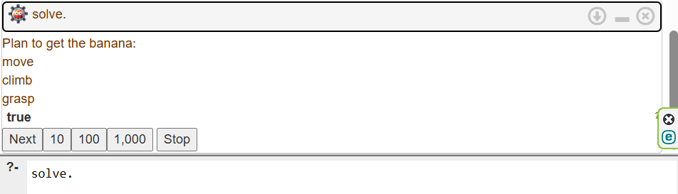

Explanation:
state(MonkeyPos, BoxPos, MonkeyStatus, BananaStatus)
- MonkeyPos: left, middle, or right
- BoxPos: same as above
- MonkeyStatus: onfloor or onbox
- BananaStatus: hasnot or hasbanana goal(state(_, _, onbox, hasbanana)).
the goal is for the monkey to be on the box and have the banana (we don’t care where the box is anymore).

Example:
state(left, middle, onfloor, hasnot)
- Monkey is on left
- Box is in the middle
- Monkey is on the floor
- Monkey doesn't have the banana

  - move/2
Move without box
  - push/2
Move with the box
Only works if monkey and box are in the same position.
  - climb/2
Climb the box
Works when monkey & box are in the same position
  - grasp/2
Take the banana
Works only in the middle, standing on the box.
  - plan/3
predicate recursively tries actions to reach the goal state.
It explores each possible action (like move, push, etc.) and builds the action sequence needed to reach the goal.

move → Monkey moves from left to middle.

push → Monkey pushes box from middle to middle (could also simulate moving it elsewhere). climb → Monkey climbs onto box in the middle.
grasp → Monkey grabs the banana!

Goal reached → state(middle, middle, onbox, hasbanana)

